[Day3-Assignment 2]: Tool chains

[vi editor]  
1. Write the content in vi editor

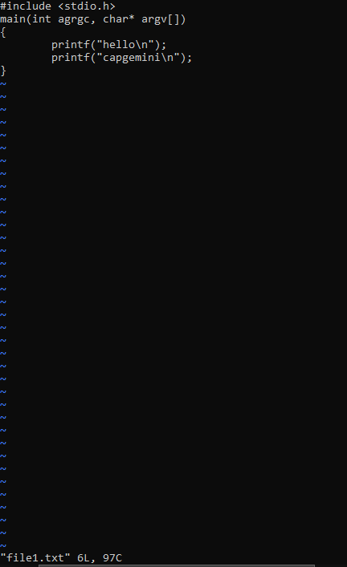

2. go to specific line number

:4(4th line)

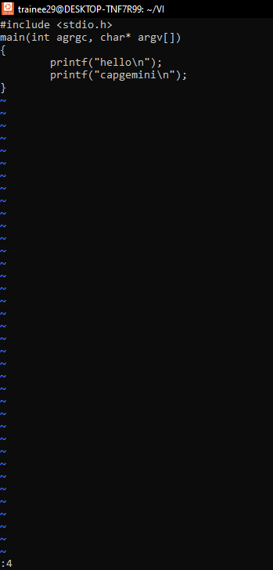

3. copy 2 lines

Nyy (N=line no.)

4. paste the copy line at location

p for paste

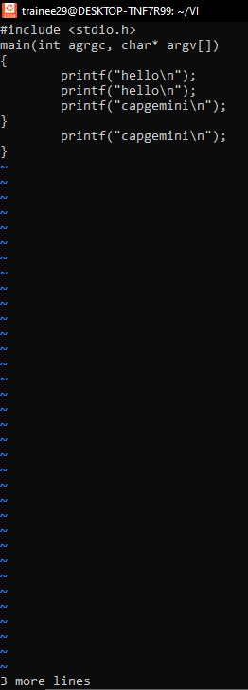

5. delete current and specific lines

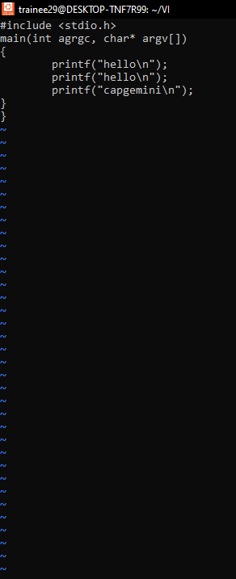

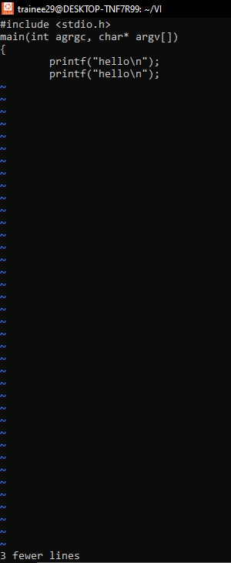

6. replace the character

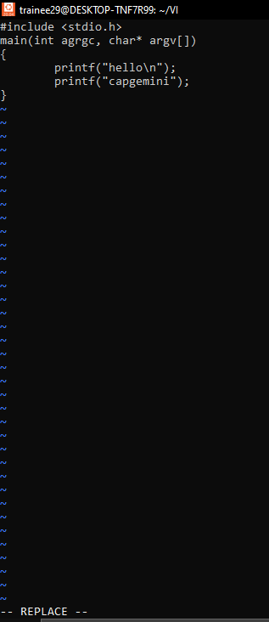

7. search string

